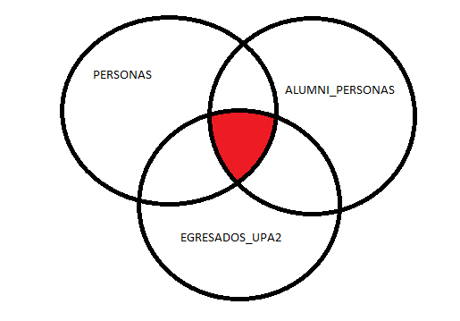

Diferencia entre las tres tablas

select protic.obtener_nombre_completo(a.pers_ncorr, 'n') as nombre,

a.pers_nrut as rutp,

b.pers_nrut as ruta,

c.pers_nrut as rute,

isnull(a.sexo_ccod, 0) as sexoenpersonas,

isnull(b.sexo_ccod, 0) as sexoenalumni_personas,

isnull(c.sexo_ccod, 0) as sexoenegresadosupa2

from personas as a

inner join alumni_personas as b

on a.pers_ncorr = b.pers_ncorr

inner join egresados_upa2 as c

on a.pers_ncorr = c.pers_ncorr

where a.sexo_ccod <> b.sexo_ccod

or a.sexo_ccod <> c.sexo_ccod

or b.sexo_ccod <> b.sexo_ccod